void setup() {
// Iniciar la comunicación serie a 9600 baudios
Serial.begin(9600);

// Configurar pines de los motores como salida
pinMode(4, OUTPUT);
pinMode(5, OUTPUT);
pinMode(6, OUTPUT);
pinMode(7, OUTPUT);
pinMode(8, OUTPUT);
pinMode(9, OUTPUT);
pinMode(10, OUTPUT);
pinMode(11, OUTPUT);

// Configurar pines de los pulsadores como entrada
pinMode(2, INPUT); // Pulsador 1
pinMode(3, INPUT); // Pulsador 2
pinMode(12, INPUT); // Pulsador 3

// Mensaje de inicio
Serial.println("Setup completo. Esperando entradas...");
}

void loop() {
// Leer el estado de los pulsadores
bool button1 = digitalRead(2) == HIGH;
bool button2 = digitalRead(3) == HIGH;
bool button3 = digitalRead(12) == HIGH;

// Imprimir el estado de los pulsadores en el Monitor Serie
Serial.print("Button1: ");
Serial.print(button1);
Serial.print(", Button2: ");
Serial.print(button2);
Serial.print(", Button3: ");
Serial.println(button3);

// Si no se presiona ningún botón, no hacer nada
if (!button1 && !button2 && !button3) {
stopMotors(); // Asegurarse de que los motores estén apagados
Serial.println("No button pressed. Motors stopped.");
delay(500); // Añadir un retraso para evitar demasiadas impresiones
return; // Salir de loop() y no hacer nada
}

if (button1) {
// Secuencia para mover hacia la derecha
Serial.println("Moving right");
digitalWrite(4, HIGH);
digitalWrite(8, HIGH);
digitalWrite(5, LOW);
digitalWrite(9, LOW);
digitalWrite(6, LOW);
digitalWrite(10, LOW);
digitalWrite(7, LOW);
digitalWrite(11, LOW);
delay(10);

digitalWrite(4, LOW);
digitalWrite(8, LOW);
digitalWrite(5, HIGH);
digitalWrite(9, HIGH);
digitalWrite(6, LOW);
digitalWrite(10, LOW);
digitalWrite(7, LOW);
digitalWrite(11, LOW);
delay(10);

digitalWrite(4, LOW);
digitalWrite(8, LOW);
digitalWrite(5, LOW);
digitalWrite(9, LOW);
digitalWrite(6, HIGH);
digitalWrite(10, HIGH);
digitalWrite(7, LOW);
digitalWrite(11, LOW);
delay(10);

digitalWrite(4, LOW);
digitalWrite(8, LOW);
digitalWrite(5, LOW);
digitalWrite(9, LOW);
digitalWrite(6, LOW);
digitalWrite(10, LOW);
digitalWrite(7, HIGH);
digitalWrite(11, HIGH);
delay(10);
} else if (button2) {
// Secuencia para mover hacia la izquierda
Serial.println("Moving left");
digitalWrite(4, LOW);
digitalWrite(8, LOW);
digitalWrite(5, LOW);
digitalWrite(9, LOW);
digitalWrite(6, LOW);
digitalWrite(10, LOW);
digitalWrite(7, HIGH);
digitalWrite(11, HIGH);
delay(10);

digitalWrite(4, LOW);
digitalWrite(8, LOW);
digitalWrite(5, LOW);
digitalWrite(9, LOW);
digitalWrite(6, HIGH);
digitalWrite(10, HIGH);
digitalWrite(7, LOW);
digitalWrite(11, LOW);
delay(10);

digitalWrite(4, LOW);
digitalWrite(8, LOW);
digitalWrite(5, HIGH);
digitalWrite(9, HIGH);
digitalWrite(6, LOW);
digitalWrite(10, LOW);
digitalWrite(7, LOW);
digitalWrite(11, LOW);
delay(10);

digitalWrite(4, HIGH);
digitalWrite(8, HIGH);
digitalWrite(5, LOW);
digitalWrite(9, LOW);
digitalWrite(6, LOW);
digitalWrite(10, LOW);
digitalWrite(7, LOW);
digitalWrite(11, LOW);
delay(10);
} else if (button3) {
// Secuencia para mover uno hacia la derecha y otro hacia la izquierda
Serial.println("Moving one motor right and the other left");
digitalWrite(4, HIGH);
digitalWrite(8, LOW);
digitalWrite(5, LOW);
digitalWrite(9, LOW);
digitalWrite(6, LOW);
digitalWrite(10, LOW);
digitalWrite(7, LOW);
digitalWrite(11, HIGH);
delay(10);

digitalWrite(4, LOW);
digitalWrite(8, LOW);
digitalWrite(5, HIGH);
digitalWrite(9, LOW);
digitalWrite(6, LOW);
digitalWrite(10, HIGH);
digitalWrite(7, LOW);
digitalWrite(11, LOW);
delay(10);

digitalWrite(4, LOW);
digitalWrite(8, LOW);
digitalWrite(5, LOW);
digitalWrite(9, HIGH);
digitalWrite(6, HIGH);
digitalWrite(10, LOW);
digitalWrite(7, LOW);
digitalWrite(11, LOW);
delay(10);

digitalWrite(4, LOW);
digitalWrite(8, HIGH);
digitalWrite(5, LOW);
digitalWrite(9, LOW);
digitalWrite(6, LOW);
digitalWrite(10, LOW);
digitalWrite(7, HIGH);
digitalWrite(11, LOW);
delay(10);
}
}

void stopMotors() {
digitalWrite(4, LOW);
digitalWrite(8, LOW);
digitalWrite(5, LOW);
digitalWrite(9, LOW);
digitalWrite(6, LOW);
digitalWrite(10, LOW);
digitalWrite(7, LOW);
digitalWrite(11, LOW);
}

apagado
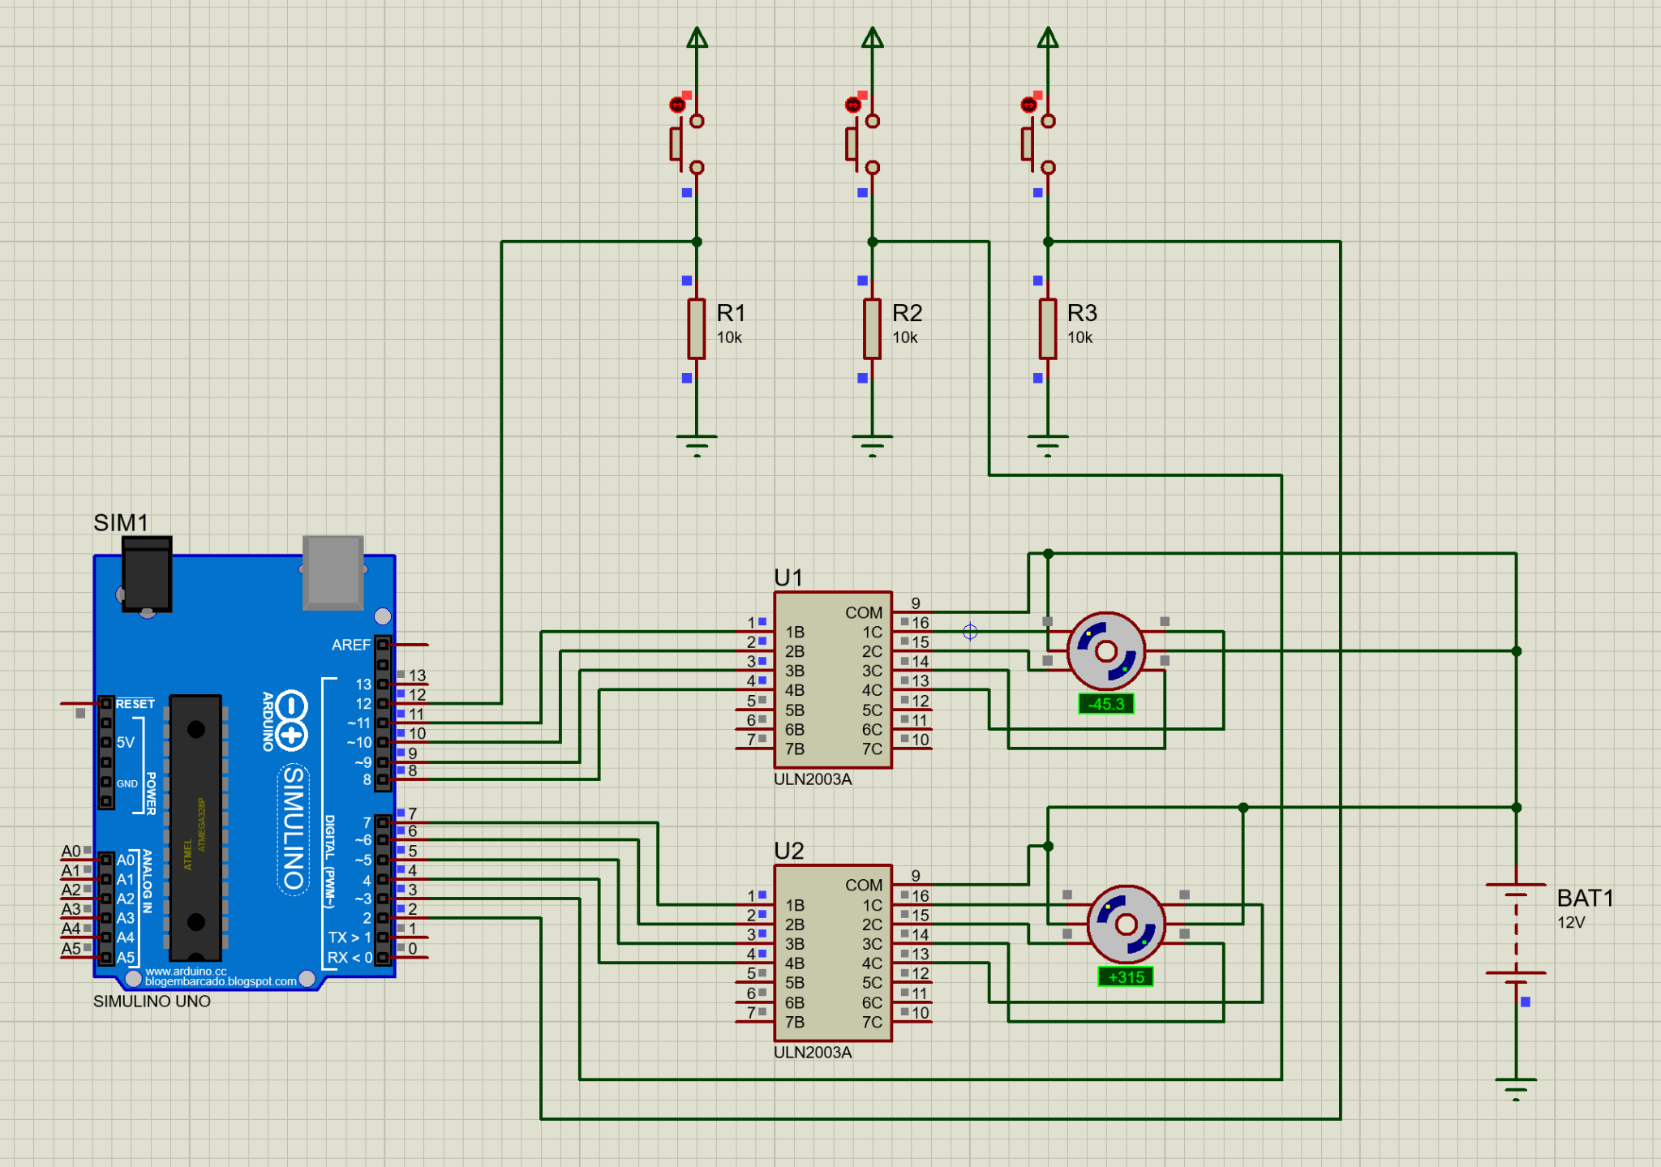
boton 1
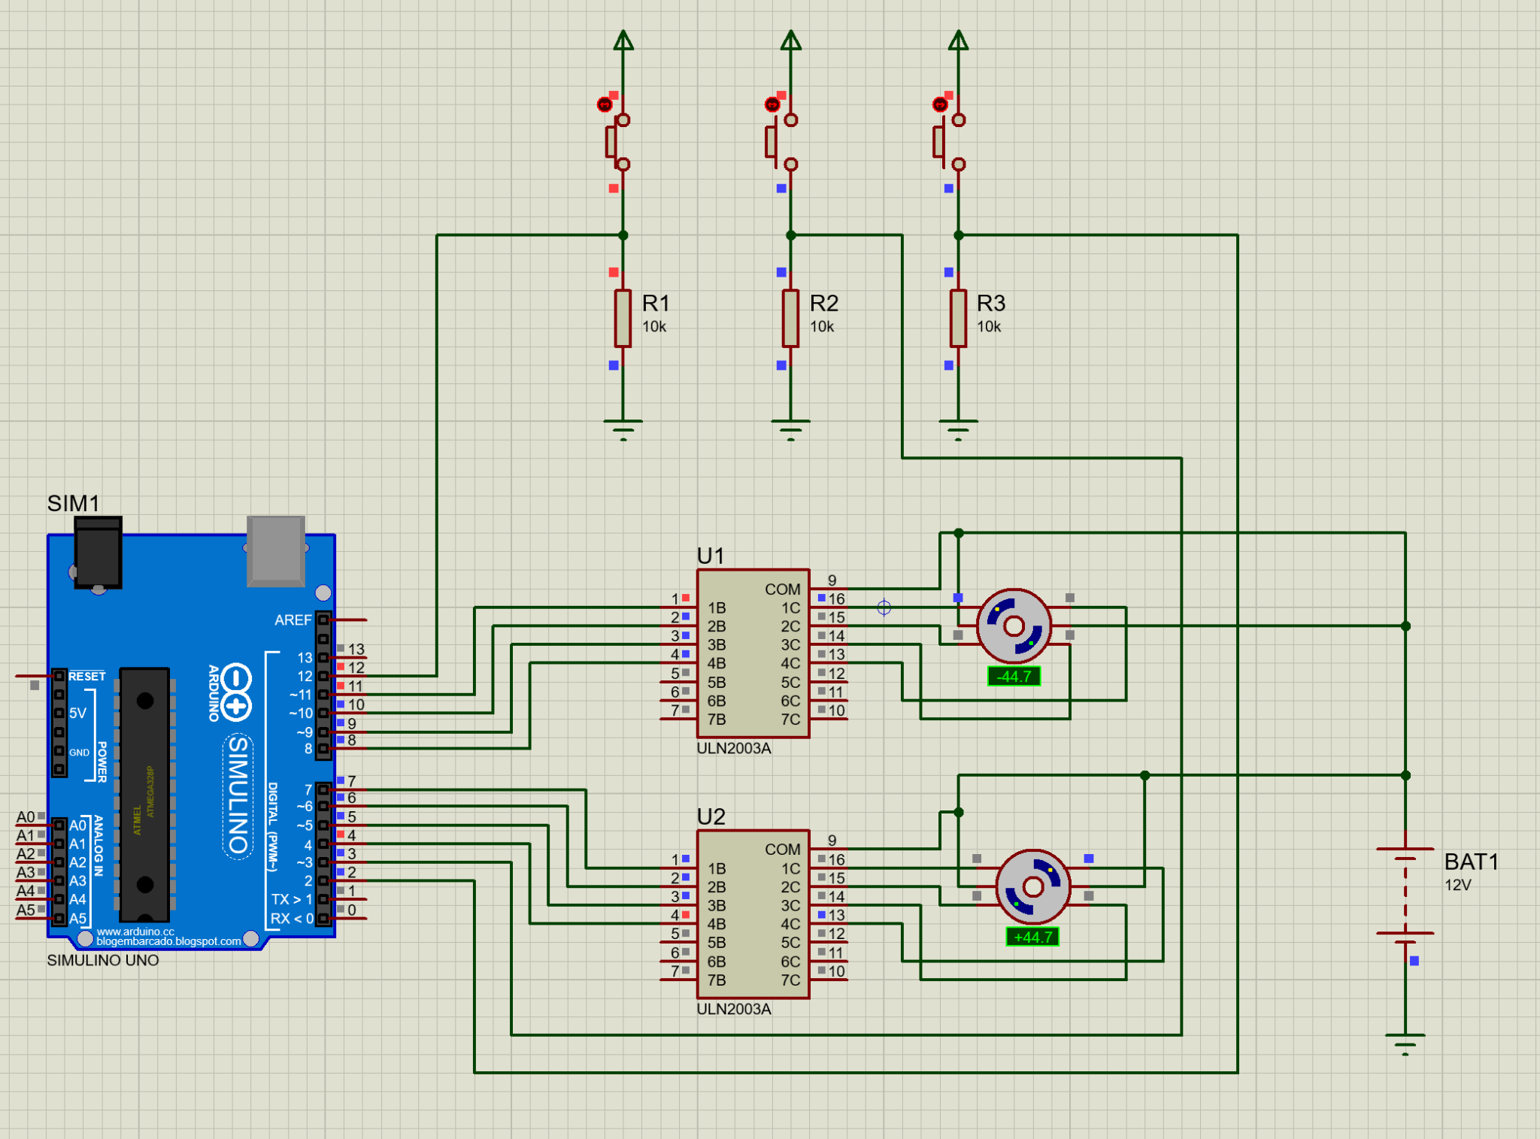
boton 2
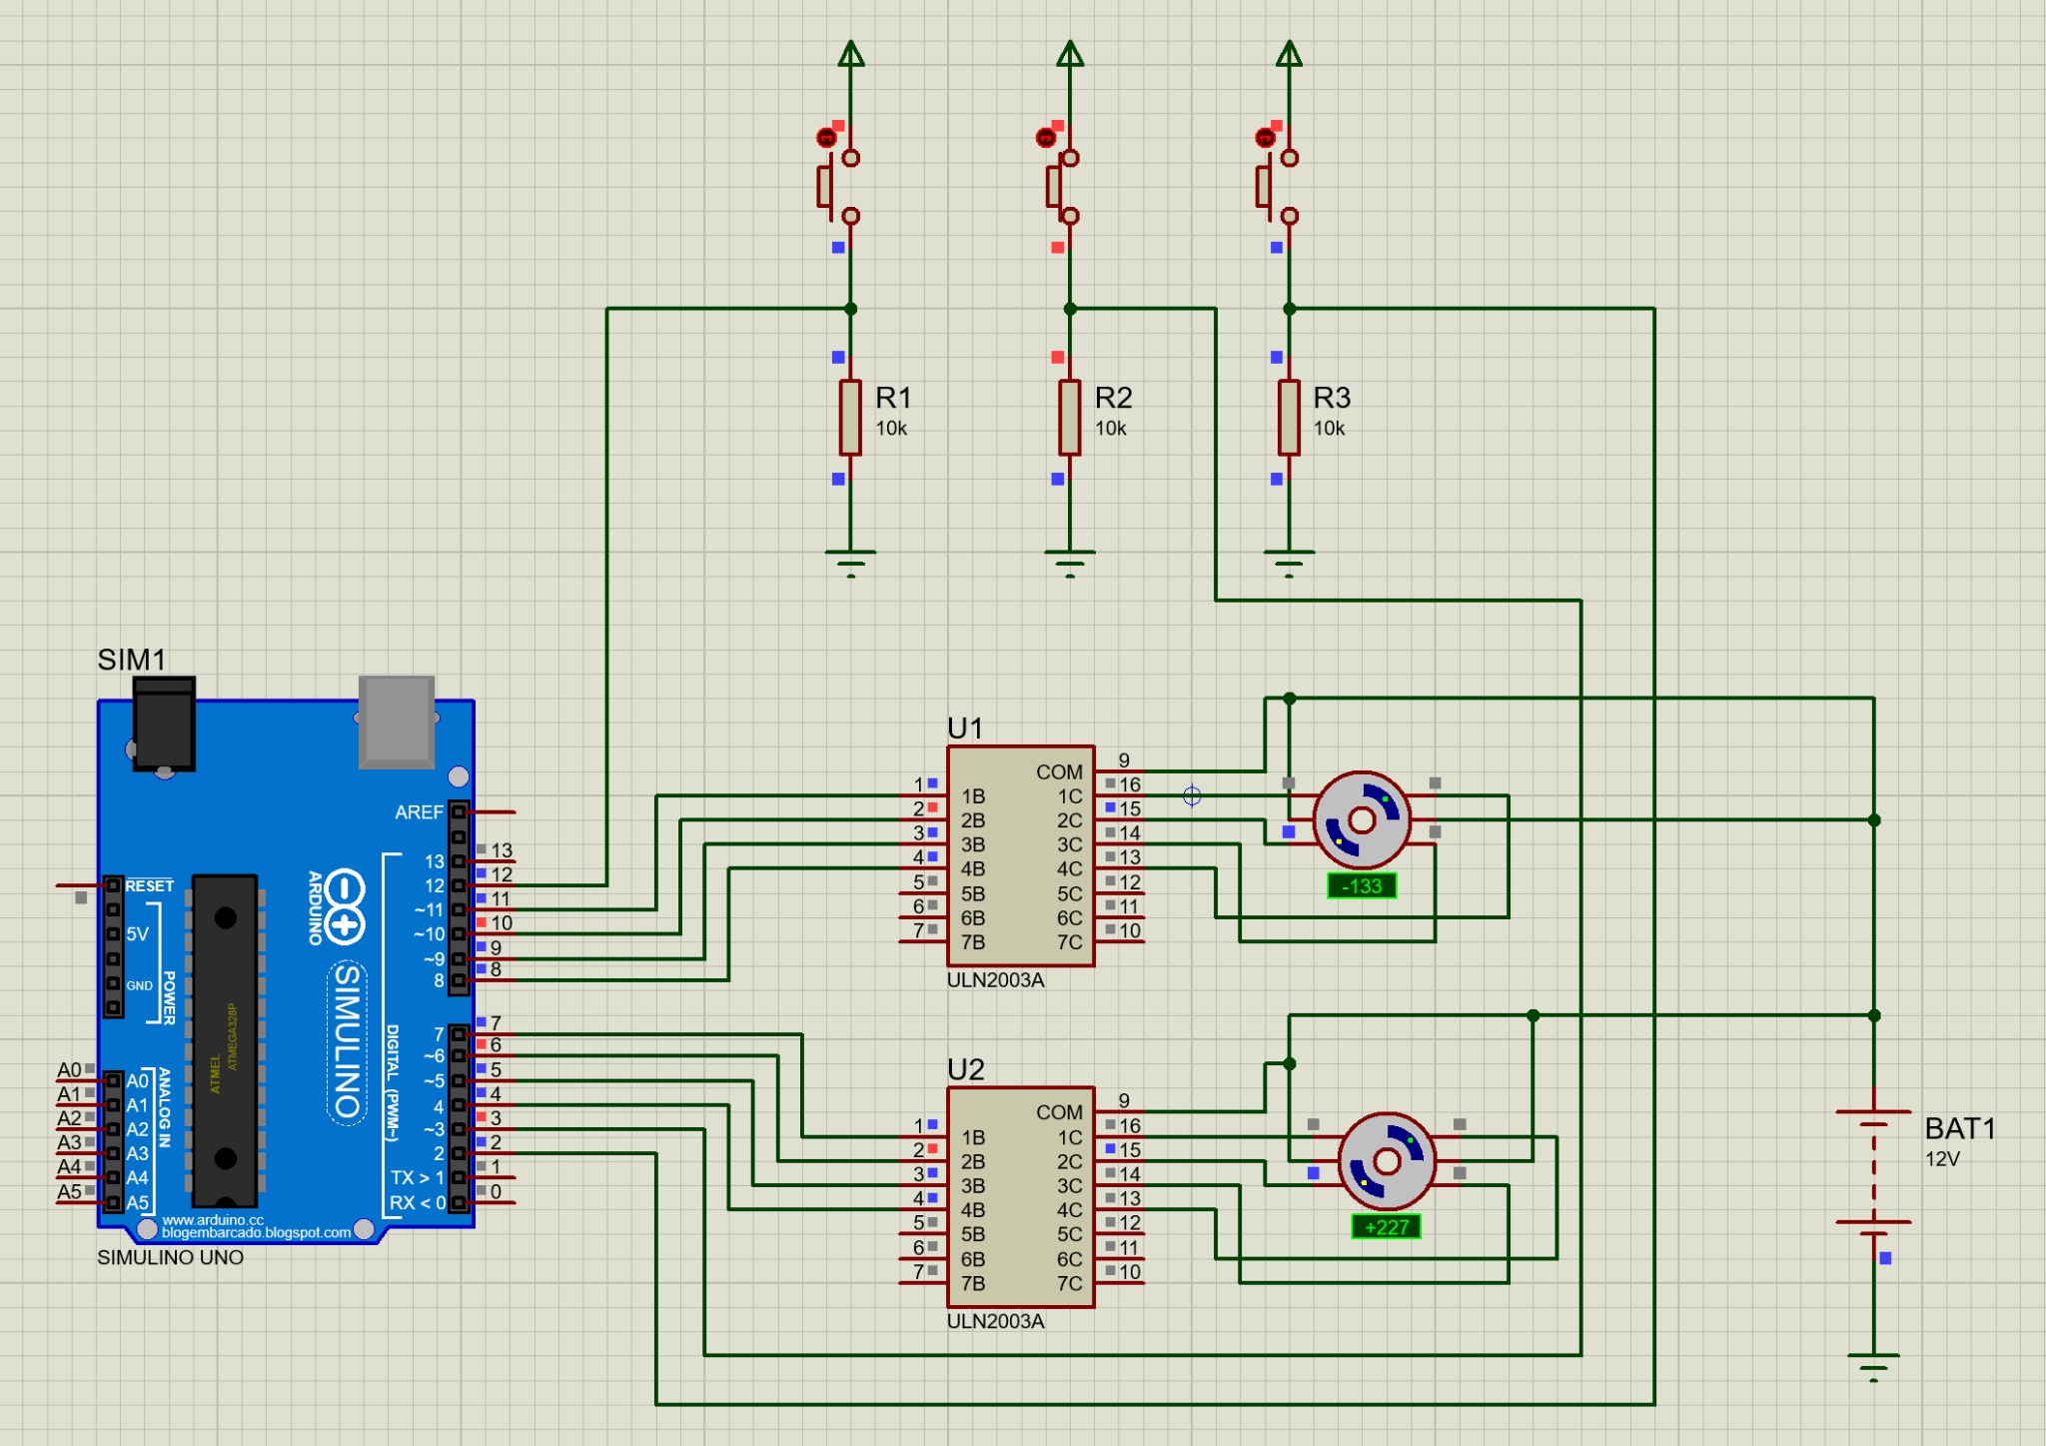
boton 3


